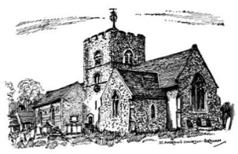
St Andrew’s Church, Boreham, CM3 3EG

Voting by email policy

As a church, it is important for there to be a clear policy on decision making when the decisions required are urgent and cannot wait until the next scheduled PCC meeting. This document outlines the procedure to be followed in order that a clear audit trail of decisions made can be maintained.

The following has been agreed by the PCC on the 1st June 2023 and will remain in place until such time as no longer required.

Aim of the policy
To ensure that decisions that are considered urgent or time critical are made by the PCC to allow for the effective running and management of the church.

Who decides what is urgent or time critical?
This decision can be made by the Vicar, Churchwarden, Treasurer in consultation with the PCC Secretary who will administer the vote. The PCC Secretary will also be the arbiter of what decisions are appropriate

Procedure
- The matter is raised with the PCC Secretary with clear reasoning for the urgency of the vote. If the decision could wait until the next PCC meeting, it will be added to the agenda.
- If urgent, the PCC Secretary compiles the email with all the relevant information attached and sends it to the PCC members with a clear deadline date for their responses.
- Responses will either be in favour, against, or abstaining and a reason for the vote is encouraged.
- Those finding the need for further information should request this as soon as possible from the PCC Secretary. All responses will be shared anonymously with the whole PCC along with the query.
- The vote will be undertaken in a closed manner to allow for honest and considered voting rather than ‘following the group’.
- The PCC Secretary will collate all the votes and then email the results, along with the comments made to allow members to understand the result of the decision.

PCC member obligations under this policy
- Members are required to respond to these requests for decision making. As a trustee of a charity, your vote is important to the managemant of the church. If you do not wish to vote, please abstain rather than not respond.
- If you are unable to reply by email, please contact the PCC Secretary with your decision, which will be recorded in confidence.

for example, requests for charitable donations in any form are not permitted under Charity Commission rules and therefore would not be circulated.

