PAROCHIAL CHURCH COUNCIL OF ST ANDREW’S, BOREHAM
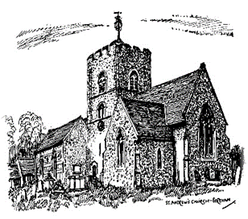
At St Andrew’s, we welcome all gifts in wills, however large or small and we promise to use your gift to make a difference to our parish. Our PCC Legacy Policy is to use gifts for the general purposes of the church in this place.
Since needs change over the years, we encourage you to leave a gift in your will for the general purposes of the parish rather than for a restricted purpose. We will discuss possible uses of your gift with your executors when the time comes, bearing in mind your known areas of interest in the church (e.g. music, buildings, children and youth, overseas mission or aid) and the church’s priorities at the time.
You can be confident that your gift will be used to make a real difference to our future mission and ministry.
We acknowledge gifts in whatever way the donor and/or his/her executors feel most appropriate. Equally, we can make sure that gifts remain anonymous if the donor prefers.
If you would like to talk to someone in confidence about the sorts of purposes your gift might fund, and how/if you would like your gift to be acknowledged, please contact
Revd Emma Wylie: - Tel. 07982723539 Email: revemswylie@gmail.com
If you would like to make a gift to our church in memoriam, please come and discuss this with us too. It can be a wonderful and appropriate way to remember a loved one.
Adopted 15th March 2021
Signed…………………………………………………………
Reviewed 13th March 2022
Reviewed 16th March 2023

